Volume plot and 3d view:
Volume is 0.85 cubic inches
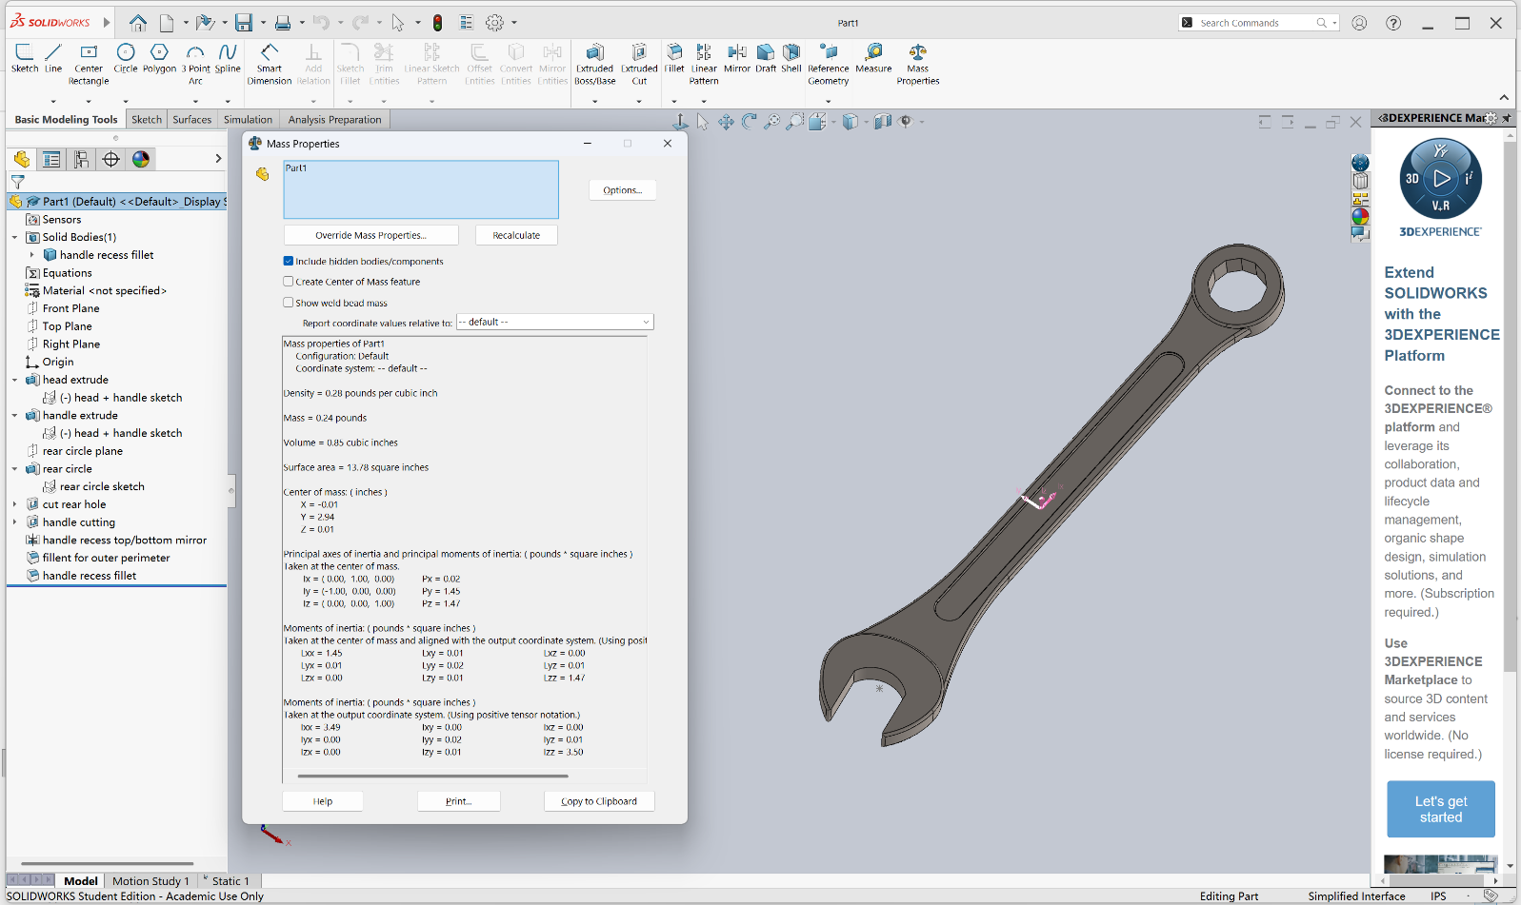

Stress plot
Maximum stress in psi is 1.110e +05
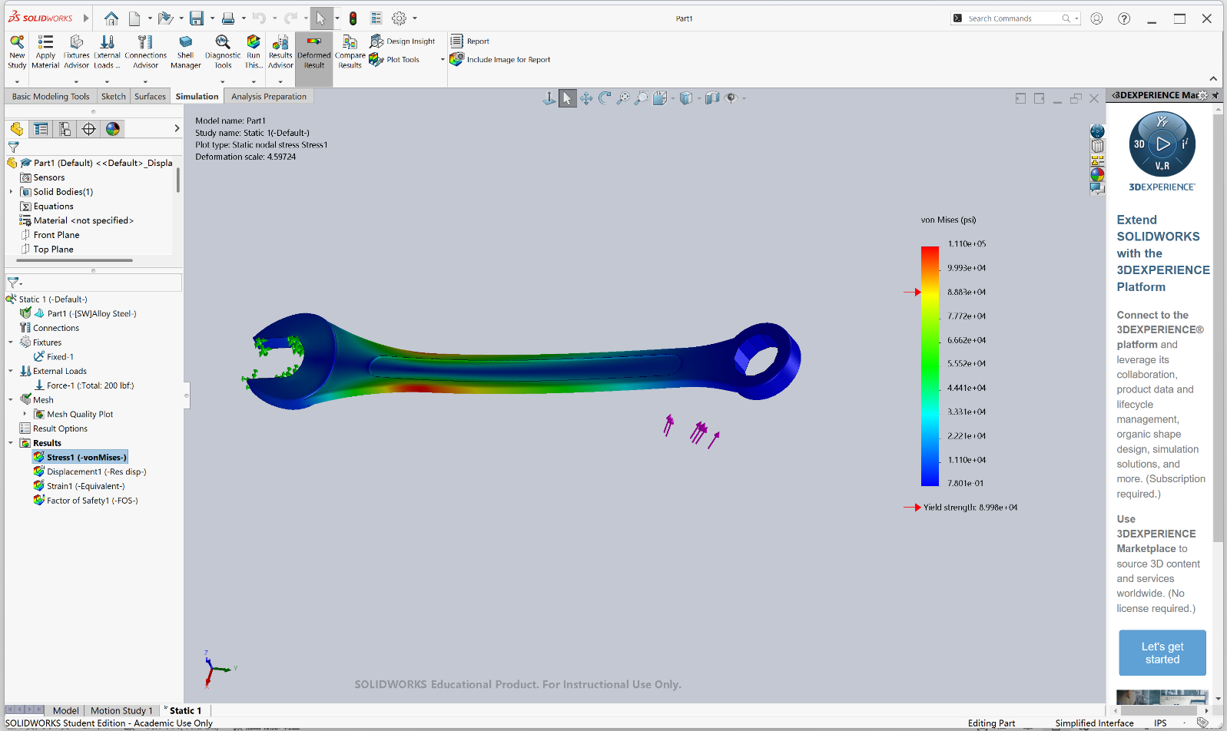

Displacement Plot
Maximum deflection in inches is 1.663e-01
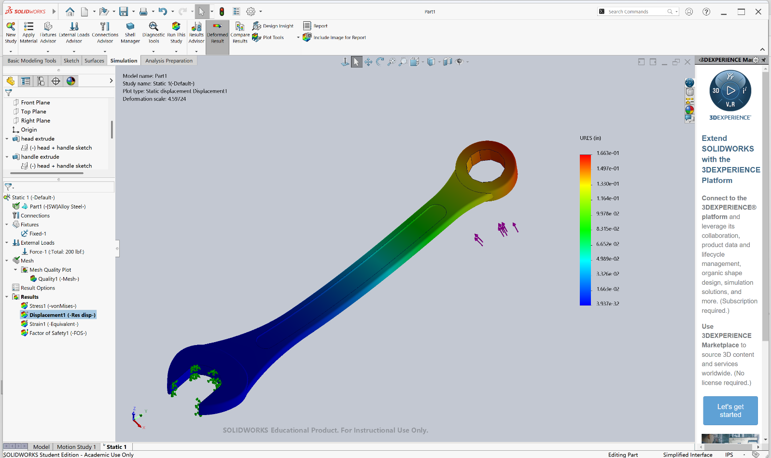

Fos plot:
FOS: 0.81
It will fail because 0.81 is smaller than 1
